A

Project Report

On..

**E-Commerce Website(Wristwatches)**

Developed By..

Hardik Parmar

&

Sachin Kava

Submitted to ..

Geetanjali College of computer science & commerce(BBA)

Saurashtra Univetsity

Rajkot

2024-25

Guided by..

Prof. Pranav Trivedi

Acknowledgements

The success and final outcome of this project required a lot of guidence and assistance from many people and I am extremely privileged to have got this all along the completion of my project all that I have done due to such supervision and assistance and I would not forget to thank them.

I would like to thank my project coordinator and my faculty guide for his valuable guidance for the project and I would like to thank my project partnet who helped me through my entire project.

**Preface**

The purpose of this E-Commerce website is to improve the user experience and their awarenesses.

The E-Commerce Website project will be used to minimize the time and the resource by enhancing product purchasing technique and seamless experience.

While the resources which minimized are workforce,money and paper etc.

The website is user-friendly and will help the watch purchasers.

**Index**

|  |  |  |
| --- | --- | --- |
| **Sr.**  **No.** | **Description** | **Page**  **No.** |
| 1 | Project Profile | 1 |
| 2 | Project Requirement | 2 |
| 3 | Technology Requirement | 2 |
| 4 | Data Flow diagram | 3 |
| 5 | ER diagram | 4 |
| 6 | Data Dictionaty | 5 |
| 7 | Screen Shots | 7 |
| 8 | Future Enhancements | 20 |
| 9 | Limitations of Project | 21 |
| 10 | Bibilography | 22 |

**Project Profile**

|  |  |
| --- | --- |
| Project Title | E-Commerce Website(Wristwatches) |
| Objective | The E-commerce Website will provide user a better experience of purchasing the Wristwatches. |
| Hardware Requirements | Pentium 90 MHz or faster and 1GB RAM or higher |
| Software Requiremnts | Python version 3.11.9 or higher,  Mysql |
| Front-End | HTML,CSS,JAVASCRIPT,Python |
| Back-End | Python Django |
| Database | SQLite |
| Others | Ms-word 2022 |

**Project Requirement**

* Hardware Requirement

|  |  |
| --- | --- |
| **Hardware Name** | **Hardware** |
| Processor | Pentium or AMD |
| storage | 20GB or Higher |
| RAM | 4GB or Higher |

**Technology Requirements**

* Software Requirements

|  |  |
| --- | --- |
| **No.** | **Software Used** |
| 1 | Python Django |
| 2 | Windows OS (Windows 10/11) |
| 3 | Visual Studio Code |

**Data Flow Diagram**

Customer

Admin

Login Update

confirmation confirmation

Website Database

**ER Diagram**

User

Category

(One to One) (One to One)

Cart

Product

(Many to Many)

(One to One) (One to One)

CartItem

Order

(Many to Many)

(One to One)

User

**Data Dictionary**

* **Product**

|  |  |  |  |  |
| --- | --- | --- | --- | --- |
| **Sr no.** | **Field Name** | **Data**  **Type** | **Size** | **Constrain** |
| 1 | id | AutoField | - | Primary Key |
| 2 | name | CharField | 200 | - |
| 3 | Description | TextField | 500 | - |
| 4 | Price | DecimalField | 10 | - |
| 5 | Image | ImageField | - | - |
| 6 | Specification | TextField | 500 | - |
| 7 | Category | CharField | 20 | - |

* **CartItem Table**

|  |  |  |  |  |
| --- | --- | --- | --- | --- |
| **Sr no.** | **Field Name** | **Data**  **Type** | **Size** | **Constrains** |
| 1 | Id | AutoField | - | Primary Key |
| 2 | cart | ForeignKey(Cart) | - | Required, CASCADE |
| 3 | product | ForeignKey(Product) | - | Required, CASCADE |
| 4 | quantity | PositiveIntegerField | - | Default: 1 |

* **Order**

|  |  |  |  |  |
| --- | --- | --- | --- | --- |
| **Sr no.** | **Field Name** | **Data**  **Type** | **Size** | **Constrains** |
| 1 | id | AutoField | - | |  | | --- | |  |  |  | | --- | | Primary Key | |
| 2 | user | ForeignKey(User) | - | Required, CASCADE |
| 3 | products | ManyToManyField(Product) | - | Required |
| 4 | address | TextField | - | |  | | --- | |  |  |  | | --- | | Required | |
| 5 | city | CharField | 100 | Default: None |
| 6 | |  | | --- | | state | | |  | | --- | | CharField | | |  | | --- | | 100 | | |  | | --- | | Default: None | |
| 7 | country | CharField | 100 | Default: None |
| 8 | pin_code | CharField | 7 | Default: '0000000' |
| 9 | payment_method | CharField | 100 | Required |
| 10 | status | CharField | 50 | Default: 'Pending' |
| 11 | total_price | Property | - | Computed total price |

* **Cart Table**

|  |  |  |  |  |
| --- | --- | --- | --- | --- |
| **Sr no.** | **Field Name** | **Data Type** | **Size** | **Constrains** |
| 1 | id | |  | | --- | |  |  |  | | --- | | AutoField | | - | Primary Key |
| 2 | user | OneToOneField(User) | - | Required, CASCADE |
| 3 | products | ManyToManyField(Product) | - | Optional |

**Screen Shots**

* **Admin Login Page**

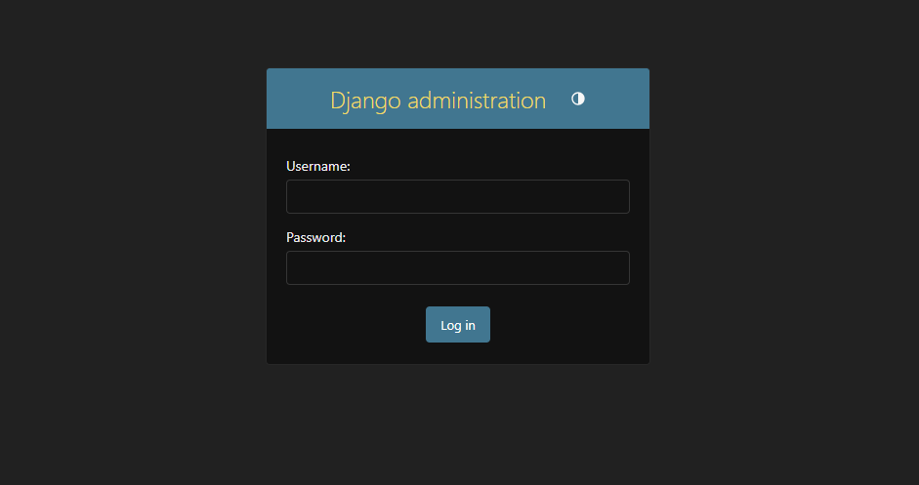

* In this page admin can enter the main page using correct username and password. It is an authentication for all admin.
* **Admin panel**

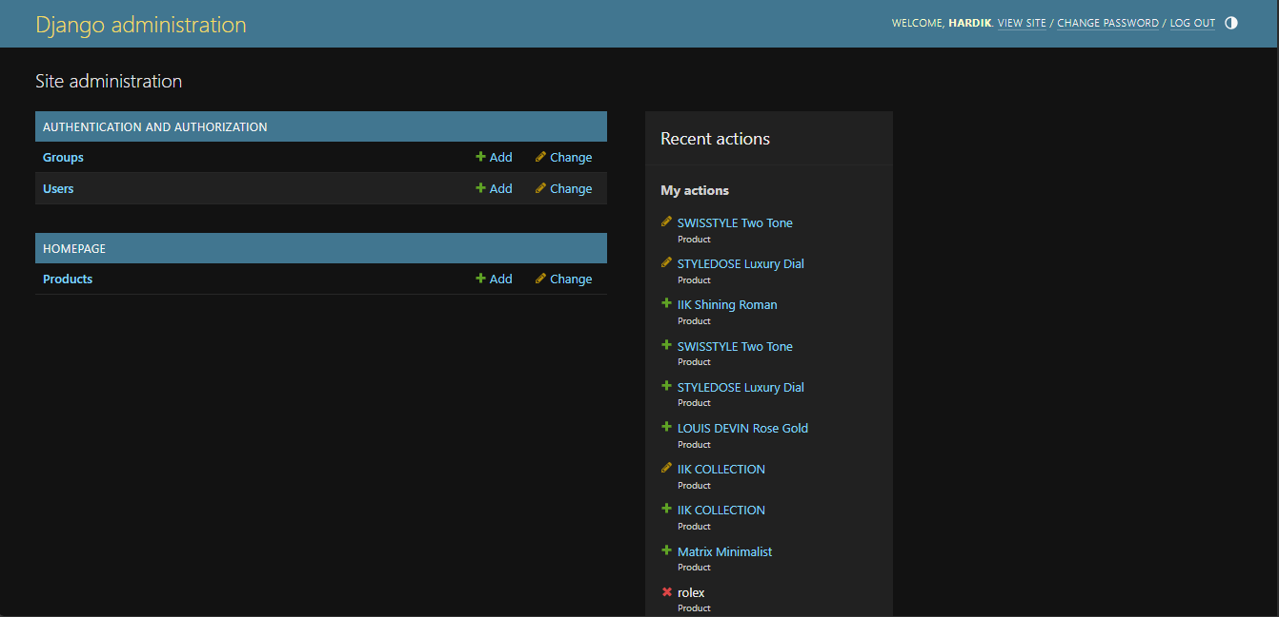

* This is the main dashboard of admin panel in this page admin can add product, user and also can view products and users.
* **Add product page**

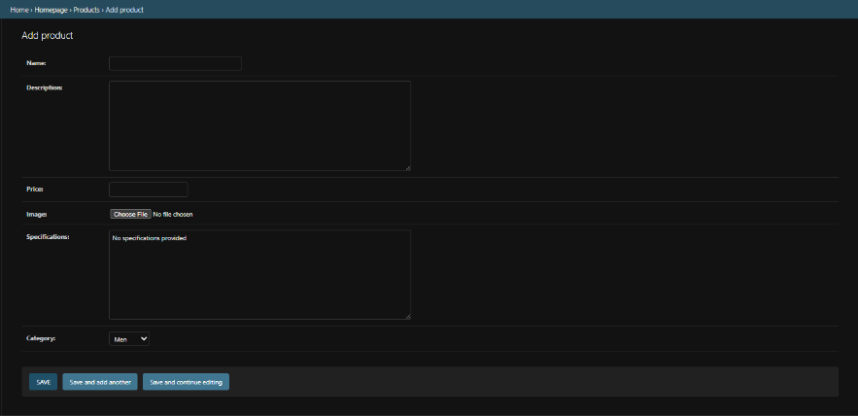

* In this page admin can add product. Admin needs to fullfill all the fields to add product.
* **Add user page**

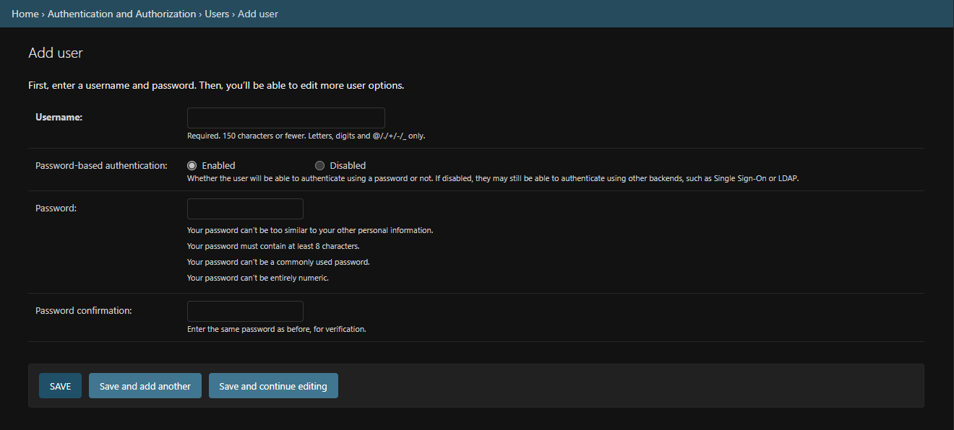

* In this page admin can add user.
* **Home page**

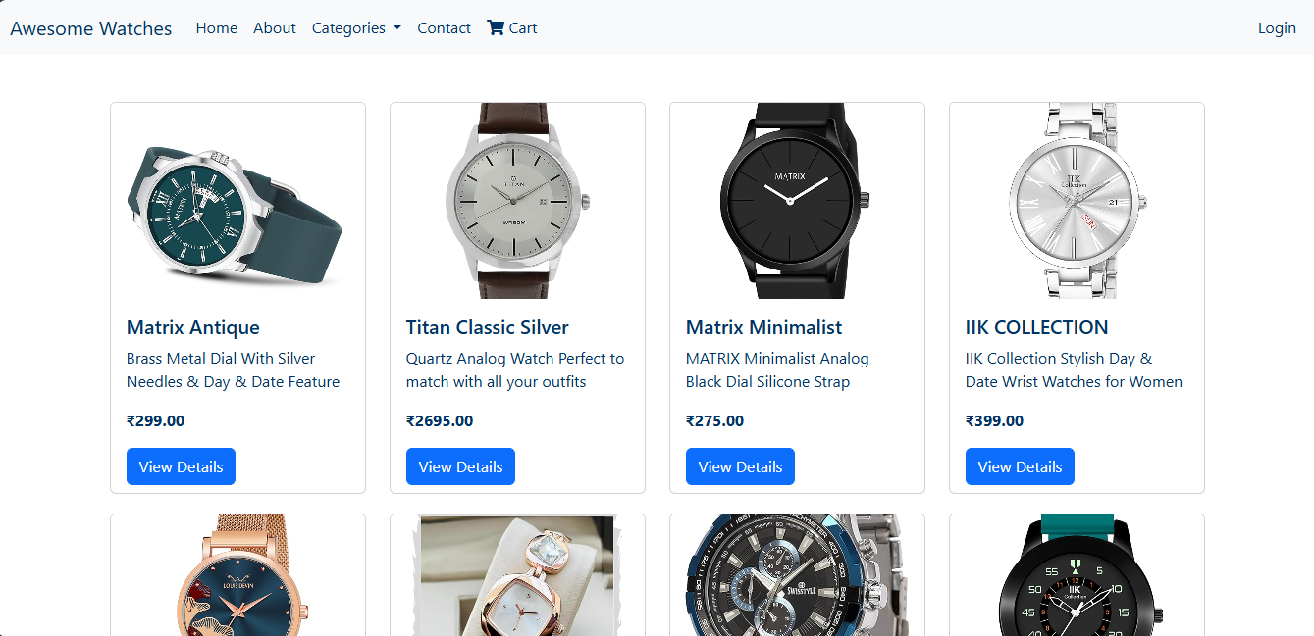

* This is the main home page of our website.
* You can see all products and the menu also can se the categories.
* **About page**

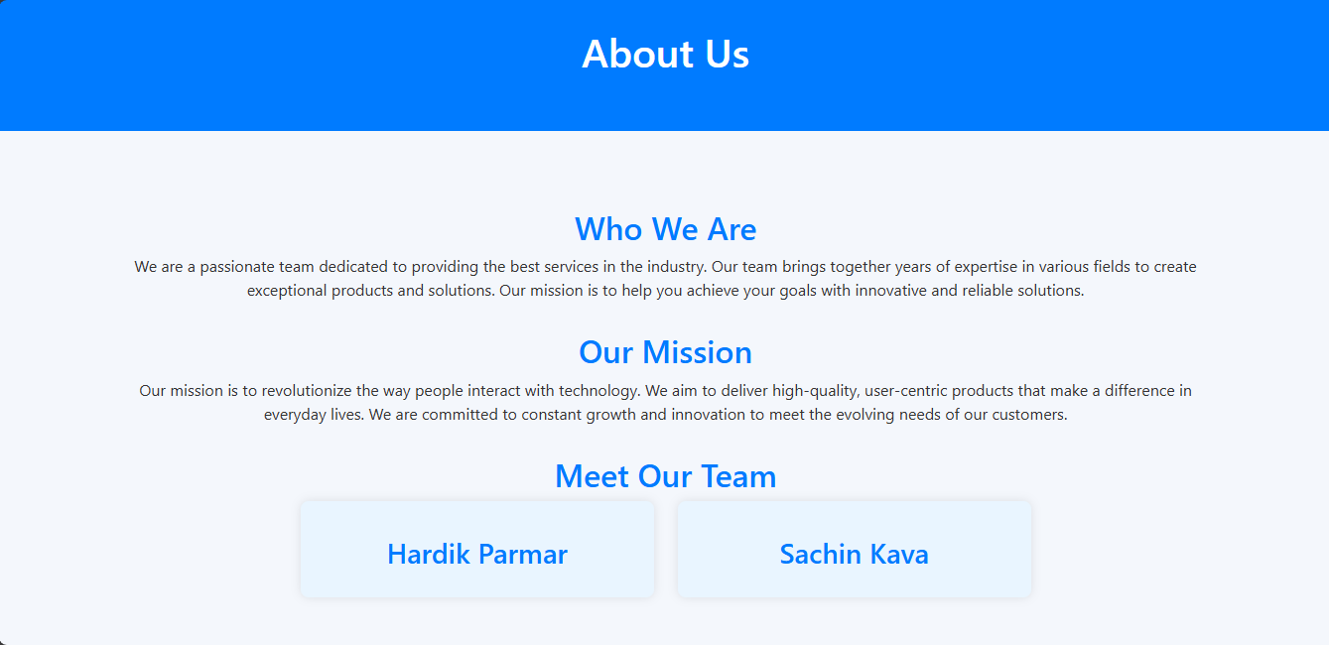

* This is the about page it contains the basic information about the website.
* **Contact Page**

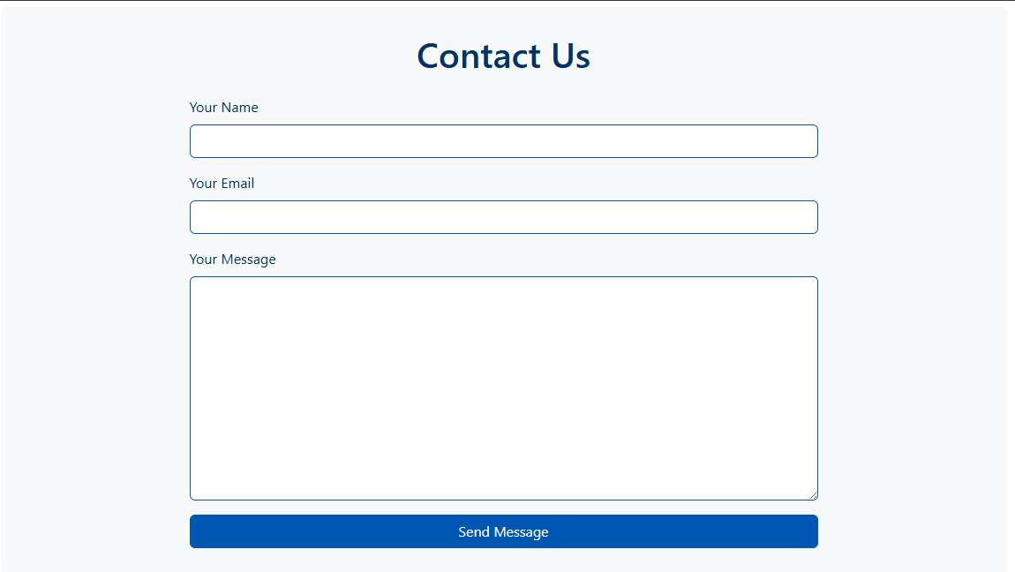

* This is the contact page it helps customer to contact with the site developers.
* **Registration page**

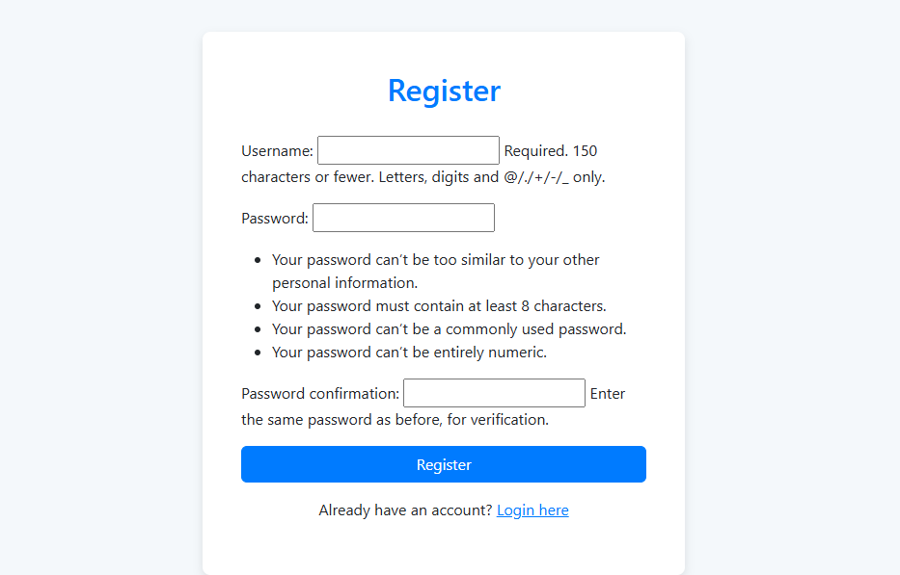

* This is the registration page where user can register themselves and then do the login into the site.
* **User Login Page**

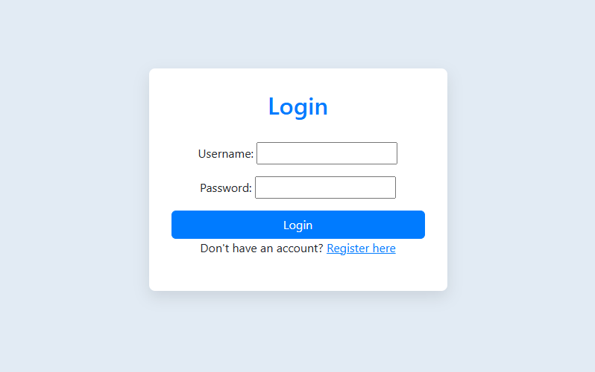

* This is the login page when user can simply enter the username and password and can login into the website.
* Also if user is not registered then user can simply just go to the registration page by clicking on the ‘register here’ link.
* **Product Detai Page**

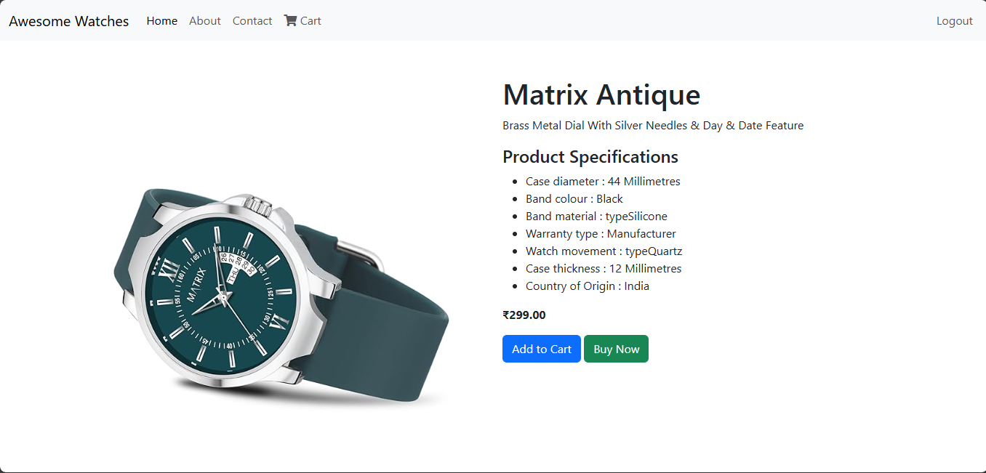

* This is the product detail page where user can see the details about the product and add to the cart if he/she wants.
* User also can go to purchase the product by simply clicking on the ‘Buy Now’ button.
* **Cart Page**

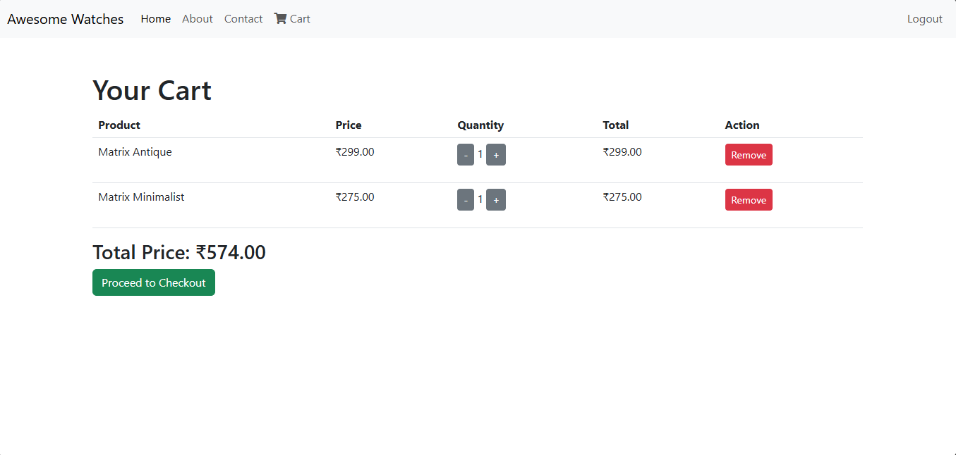

* This is the user cart page.
* User can only see the cart page if he/she is logged in.
* In this page user can see all the products and its quantity and price which user added to that cart.
* **Checkout Page**

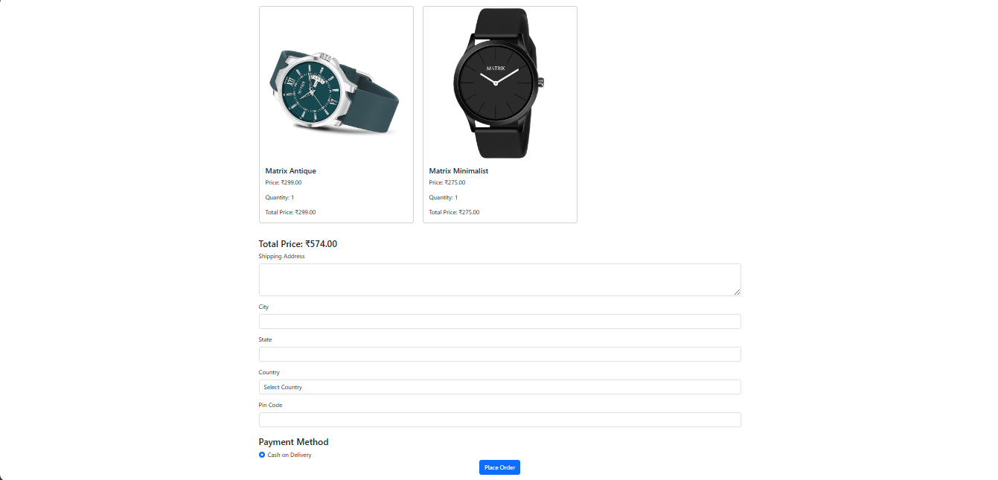

* This is the checkout page where user can enter the address where user wants its product to be delievered.
* Down there is the payment method which is only ‘cash on delievery’.
* **Order Summary Page**

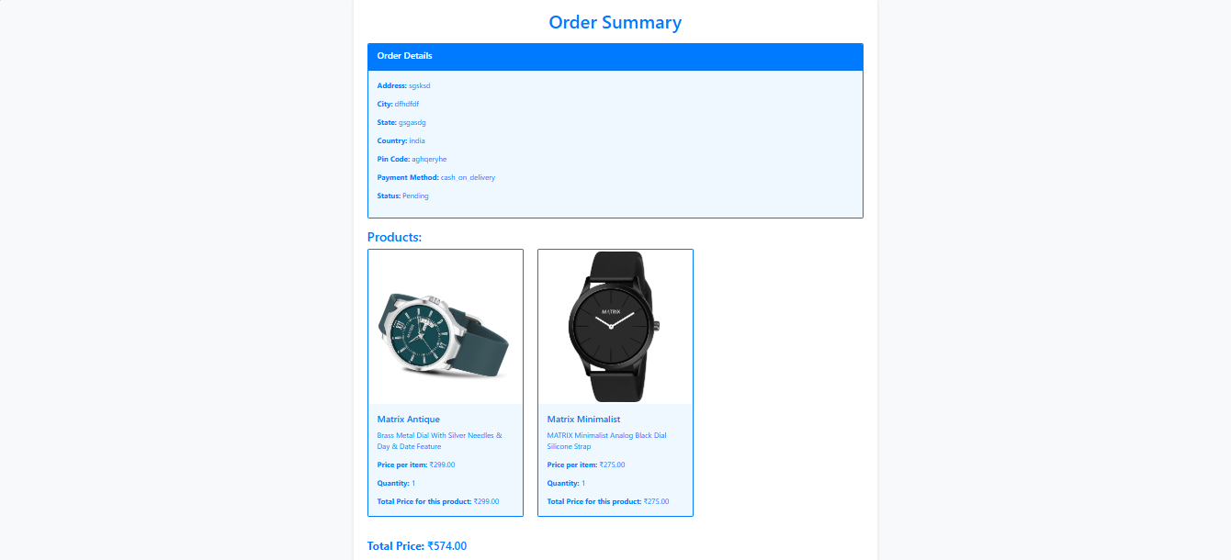

* This page is order summary page.
* In this page user can see the order’s all details and total price that has to be paid.

**Future Enhancements**

Our software “Library Management System” which provides complete information about Users like Student and admin.

We will add more content on them in future. In our web-based application right now, only Books and Users with their information available but in future we will add Online Lectures, Links, etc.

We will also provide more images in GUI related to our software in future. We will try to find out more about this topic and add in future. We will try to make this application more attractive so that visitor cannot get bored while using it.

**Limitations**

* **User Limitations**:
* **Concurrent Users**:

The system may struggle with performance if too many users access it simultaneously, leading to slow response times or crashes.

* **User Authentication**:

Limited user authentication methods may expose the system to unauthorized access.

* **Functionality Limitations**:
* **Search Functionality**:

Basic search capabilities may not support advanced queries, such as filtering by multiple criteria.

* **Reporting**:

Limited reporting features may restrict users from generating customized reports on user activity or inventory status.

**Bibliography**

* <https://www.w3schools.com/python/>
* <https://stackoverflow.com/questions/tagged/python>